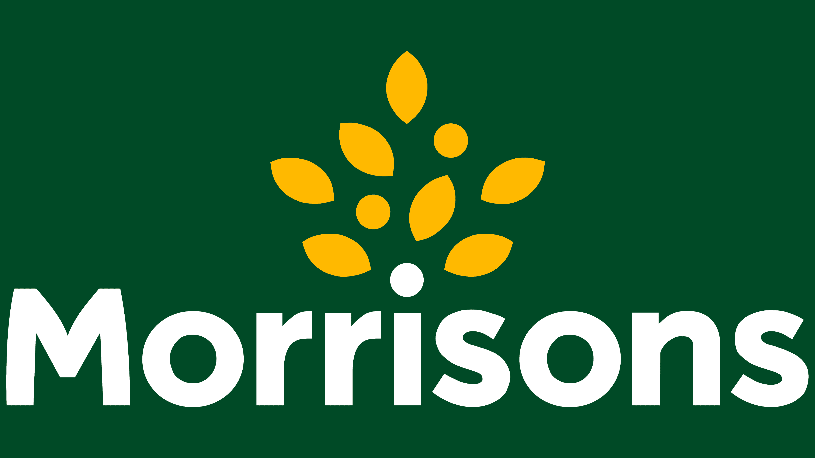

Men Do Events and Activity Programme

February 2022
Chinese New Year Celebration Thursday 3rd 7pm
China Rose, 34 High Street, Mablethorpe, LN12 1AD
Tai Pan, 138 Eastgate, Louth, LN11 9AA
Virtual Bingo Thursday 10th 7:30pm – Zoom
Light-hearted online bingo, with real prizes to be won. Women welcome to this event.
Bowls Or Bowling
Tuesday 22nd 12pm – Skegness Empire Bowl & Bar, Grand Parade, PE25 2UG. Two games of ten pin bowling, followed by a drink in the bar.
Thursday 24th 11:45am – Louth Indoor Bowls, Birch Rd, Louth, LN11 8DU. Have a try at bowls with tuition from the pros. Followed by food in the cafe.

March 2022
National Coal Mining Museum Thursday 3rd 11am – 3:15pm
180 years of coal mining history set out in acres of woodland. The visit includes a tour 140m underground. There is opportunity to then have lunch in the on-site café.
Transport included for this event, collecting from Skegness, Mablethorpe and Louth, starting 7:30am. To make this trip available to all, we have included +1’s which is open to women.
Pub Games Night
Friday 11th 7pm at The Louth, High Street, Mablethorpe, LN12 1AF
Wednesday 16th 7pm at The Woolpack Inn, Louth, LN11 0DA
Classics like dominoes, cards, connect four and Jenga. Light bites provided.
Easter Brunch Wednesday 30th 10:30am at Farmer Browns Ice Cream Parlour, Woodrow Farm, Huttoft, Alford, LN13 9RL
An easter themed brunch in a relaxed atmosphere.

Masons Banter Breakfasts
We have been fortunate to receive funding from The Freemasons which has enabled us to provide a regular free breakfast for men at local cafes on the 1st Tuesday of every month, 9am-11am. This can be used as an opportunity to get out and meet new people, or even just take an hour to yourself whilst enjoying a fry up.

There is no need to book these breakfasts, just get in touch to request your membership card which must be shown whilst ordering your food.

Spilsby – The Cornhill Café – 5 Cornhill, PE23 5JP
Mablethorpe – The Louth – High Street, LN12 1AF
Louth – The Trinity Centre – Eastgate, Louth, LN11 8DJ
Horncastle – The Bridge – 17 Bridge St, Horncastle, LN9 5HZ
Alford – Farmer Browns – Woodrow Farm, Huttoft, Alford, LN13 9RL
Wainfleet – Filling Station, 40 High St, Wainfleet All Saints, PE24 4BN
Skegness – Morrisons Store Café – Wainfleet Rd, PE25 3NZ

